Web Designing

External viva

Made by- Vansh Sukhija

Roll no- 12112021

Section- CS-A2

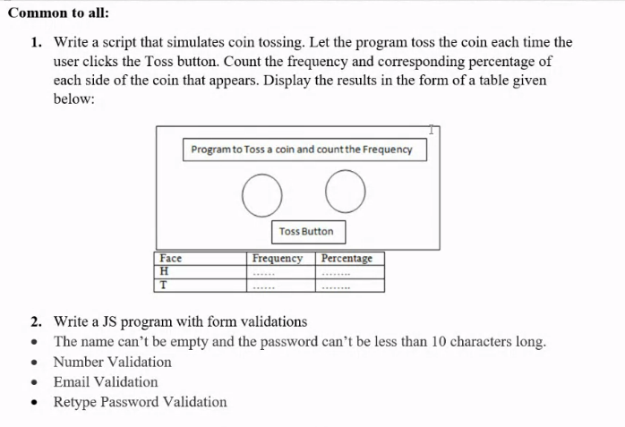

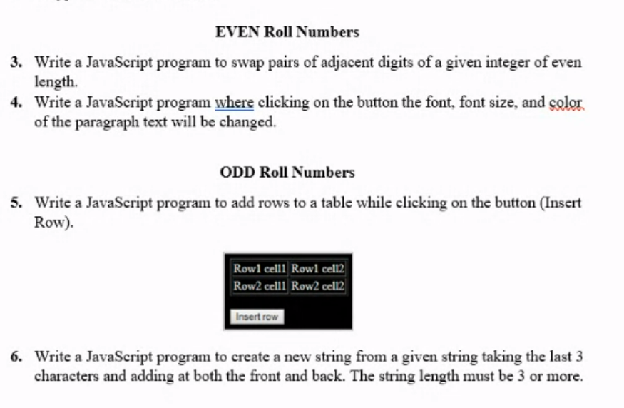

Common to All-

1-

<!DOCTYPE html>

<html lang="en">

<head>

    <meta charset="UTF-8">

    <meta http-equiv="X-UA-Compatible" content="IE=edge">

    <meta name="viewport" content="width=device-width, initial-scale=1.0">

    <title>toss coin</title>

    <style>

        .border {

*border-radius*: 5px;

*border-width*: 10px;

*border-style*: solid;

*border-color*: black;

*background-color*: aquamarine;

        }

        .border2 {

*border-width*: 4px;

*border-style*: solid;

*border-color*: black;

*display*: inline-block;

*margin-left*: auto;

*padding*: 20px;

*background-color*: rgb(181, 250, 227);

        }

        .big {

*font-size*: larger;

        }

        td {

*padding*: 20px;

*background-color*: rgba(0, 238, 255, 0.762);

*opacity*: 75%;

        }

        th {

*padding*: 20px;

*background-color*: rgba(0, 238, 255, 0.762);

        }

        .inline {

*margin*: 2%;

*font-size*: 50px;

*display*: inline;

*background-color*: yellow;

        }

        img{

*width*: 270px;

        }

    </style>

</head>

<body style="background-color: orange;">

    <div class="border">

        <center>

            <h1 class="border2">Program to Toss a coin and count its frequency</h1>

        </center>

        <br>

        <center>

            <div class="inline" id="head">

                <span>HEAD</span>

            </div>

            <div class="inline" id="tail">

                <span>TAILS</span>

            </div>

            <br>

            <br><br>

            <button class="big" onclick="toss()">Toss Coin</button>

            <br>

            <br>

        </center>

    </div>

    <center>

        <table style="font-size: 40px; text-align: center; table-layout: fixed; width: 750px;">

            <tbody>

                <tr>

                    <th>Face</th>

                    <th>Frequency</th>

                    <th>Percentage</th>

                </tr>

                <tr>

                    <td>Head</td>

                    <td id="hf">0</td>

                    <td id="hp">0</td>

                </tr>

                <tr>

                    <td>Tail</td>

                    <td id="tf">0</td>

                    <td id="tp">0</td>

                </tr>

            </tbody>

        </table>

    </center>

    <script>

*var* y = 0, z = 0;

*function* toss() {

*let* x = Math.floor(Math.random() \* 100 + 1);

            if (x % 2 == 0) {

                document.getElementById("hf").innerHTML++;

                y++;

*let* one = 100 \* y / (y + z);

*let* two = 100 \* z / (y + z);

                document.getElementById("head").style.backgroundColor = "green";

                document.getElementById("tail").style.backgroundColor = "yellow";

                document.getElementById("hp").innerHTML = one.toFixed(2);

                document.getElementById("tp").innerHTML = two.toFixed(2);

            }

            else {

                document.getElementById("tf").innerHTML++;

                z++;

*let* one = 100 \* y / (y + z);

*let* two = 100 \* z / (y + z);

                document.getElementById("tail").style.backgroundColor = "green";

                document.getElementById("head").style.backgroundColor = "yellow";

                document.getElementById("hp").innerHTML = one.toFixed(2);

                document.getElementById("tp").innerHTML = two.toFixed(2);

            }

        }

    </script>

</body>

</body>

</html>

Output-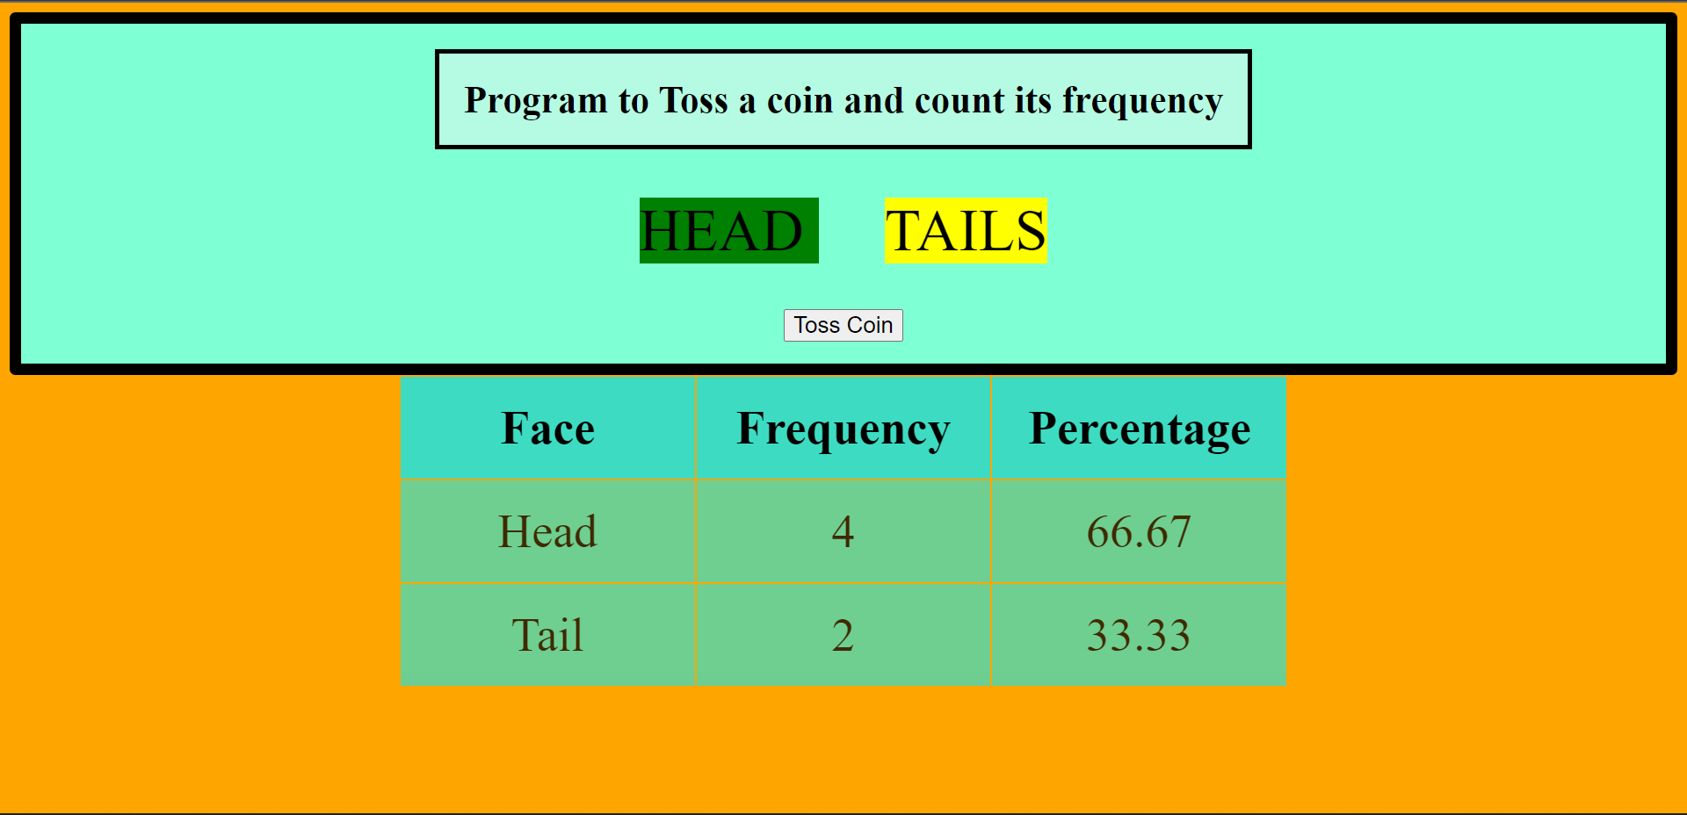

2-

<!DOCTYPE html>

<html lang="en">

<head>

    <meta charset="UTF-8">

    <meta http-equiv="X-UA-Compatible" content="IE=edge">

    <meta name="viewport" content="width=device-width, initial-scale=1.0">

    <title>Form Validation</title>

    <style>

        h1{

*text-align*: center;

*color*: crimson;

*font-size*: 65px;

        }

        body{

*background-color*: azure;

        }

        #name, #pass, #mail, #pass2, #num{

*width*: 200px;

*height*: 30px;

*margin-left*: 35%;

        }

        label{

*font-size*: larger;

*margin-left*: 35%;

*margin-bottom*: 2%;

        }

        form{

*width*: 50%;

*border*: 2px;

*border-style*: solid;

*margin-left*: 25%;

*background-color*: blanchedalmond;

        }

        #sub, #res{

*width*: 100px;

*height*: 40px;

*margin-top*: 3%;

*background-color*: rgb(184, 201, 233);

        }

    </style>

</head>

<body>

    <h1>Form Validation</h1>

    <form name="form1">

        <label for="name">Name: </label><br>

        <input type="text" id="name" name="name" placeholder="Enter your name"><br><br>

        <label for="mail">Email: </label><br>

        <input type="text" id="mail" name="mail" placeholder="Enter your email id"><br><br>

        <label for="pass">Password: </label><br>

        <input type="password" id="pass" name="pass" placeholder="Enter your password"><br><br>

        <label for="pass2">Confirm Password: </label><br>

        <input type="password" id="pass2" name="pass2" placeholder="Enter your password again"><br><br>

        <label for="num">Phone: </label><br>

        <input type="number" id="num" name="num" placeholder="Enter your phone number"><br><br>

    </form>

    <input type="submit" value="Submit" id="sub" onclick="return validate()" style="margin-left: 42%;">

    <input type="reset" value="Reset" id="res">

    <script>

*let* a = document.forms["form1"]["name"];

*let* b = document.forms["form1"]["mail"];

*let* c = document.forms["form1"]["pass"];

*let* d = document.forms["form1"]["pass2"];

*let* e = document.forms["form1"]["num"];

*let* str = (*String*)(c.value);

*let* str2 = (*String*)(e.value);

*let* flag = 1;

*function* validate(){

            if(a.value==''){

                flag = 0;

                alert("Name can't be empty");

            }

            if(!b.value.includes("@")){

                flag = 0;

                alert("Format of your email in incorrect");

            }

            if(str.length<10){

                flag = 0;

                alert("Length of password is less than 10");

            }

            if(c.value!=d.value){

                flag = 0;

                alert("Your passwords doesn't match");

            }

            if(str2.length<10){

                flag = 0;

                alert("Length of your phone number is not 10 characters");

            }

            return flag;

        }

    </script>

</body>

</html>

Output-

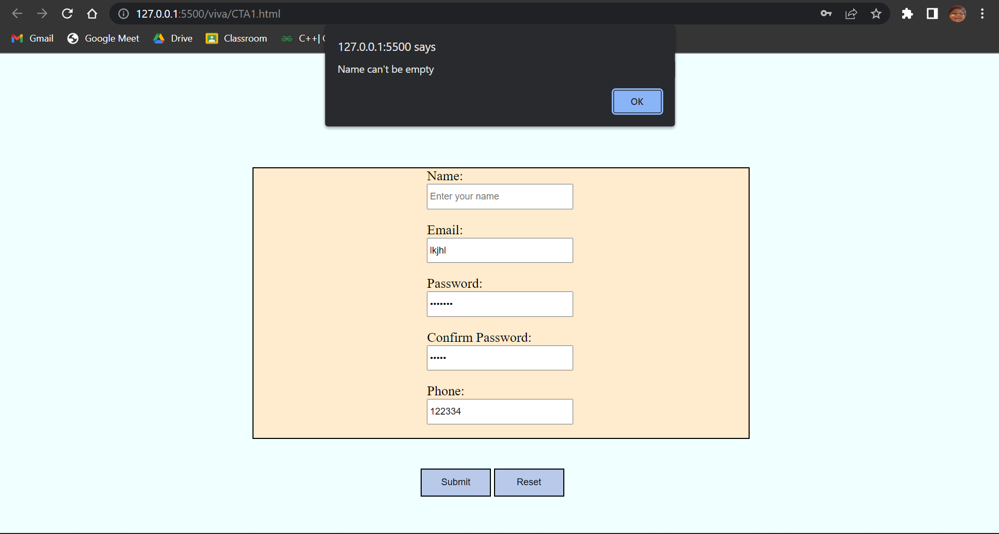

For Odd roll numbers-

<!DOCTYPE html>

<html>

<head>

    <meta charset="UTF-8">

    <meta http-equiv="X-UA-Compatible" content="IE=edge">

    <meta name="viewport" content="width=device-width, initial-scale=1.0">

    <title>Adding rows</title>

</head>

<body>

    <p>Click the buttons to create and delete row(s) for the table.</p>

    <table id="myTable" border="2px" style="border-collapse: collapse; width: 25%;">

        <tr>

            <td>Row1 cell1</td>

            <td>Row1 cell2</td>

        </tr>

        <tr>

            <td>Row2 cell1</td>

            <td>Row2 cell2</td>

        </tr>

        <tr>

            <td>Row3 cell1</td>

            <td>Row3 cell2</td>

        </tr>

    </table>

    <br>

    <button onclick="myCreateFunction()">Create row</button>

    <script>

*function* myCreateFunction() {

*var* table = document.getElementById("myTable");

*var* row = table.insertRow(0);

*var* cell1 = row.insertCell(0);

*var* cell2 = row.insertCell(1);

            cell1.innerHTML = "NEW CELL";

            cell2.innerHTML = "NEW CELL";

        }

    </script>

</body>

</html>

Output-

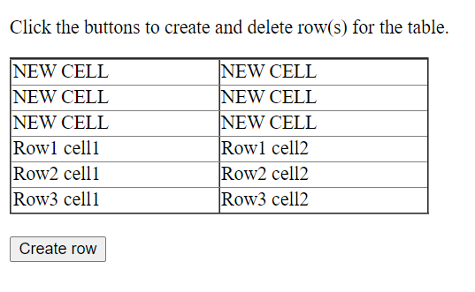

2-

<!DOCTYPE html>

<html lang="en">

<head>

    <meta charset="UTF-8">

    <meta http-equiv="X-UA-Compatible" content="IE=edge">

    <meta name="viewport" content="width=device-width, initial-scale=1.0">

    <title>Document</title>

</head>

<body>

    <div>

        <p id="string1">String you entered: </p>

    </div>

    <div id="show">New String: </div>

    <script>

*let* str1 = prompt("Enter a string: ");

*let* len = str1.length;

*let* str2 = str1[len-3]+str1[len-2]+str1[len-1]+str1+str1[len-3]+str1[len-2]+str1[len-1];

*let* a = document.getElementById("string1");

*let* b = document.getElementById("show");

        a.innerHTML += str1;

        b.innerHTML += str2;

    </script>

</body>

</html>

Output-

